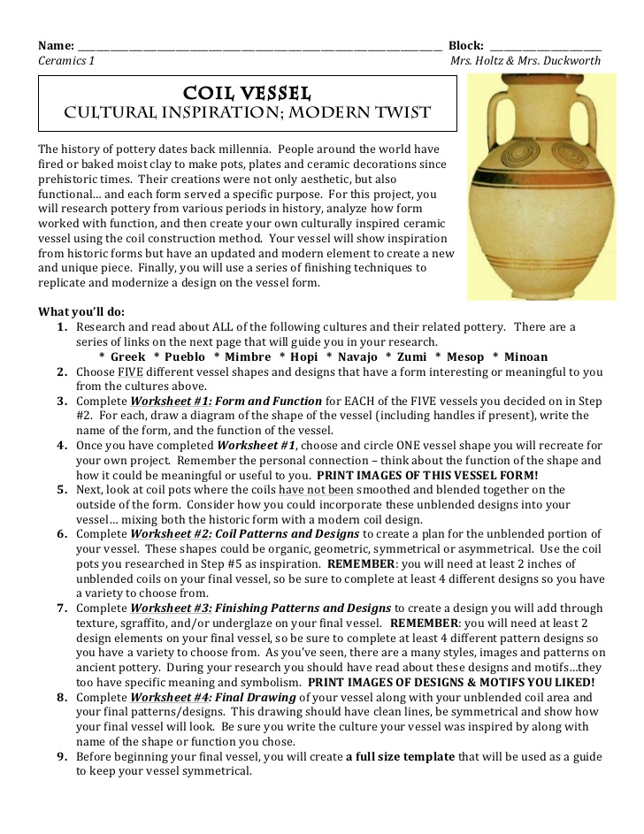Name: _________________________________________

COIL VESSEL

CULTURAL INSPIRTATION : MODERN TWIST

The history of pottery dates back millennia. People around the world have fired or baked moist clay to make pots, plates and ceramic decorations since prehistoric times. Their creations were not only aesthetic, but also functional…and each form served a specific purpose. For this project, you will research pottery from various periods in history, analyze how form worked with function, and then create your own culturally inspired ceramic vessel using the coil construction method. Your vessel will show inspiration from historic forms but have an updated and modern element to create a new and unique piece. Finally, you will use a series of finishing techniques to replicate and modernize a design on the vessel form.

**What you’ll do:**

1. Research and read about ALL of the following cultures and their related pottery. There are a series of links on my homepage that will guide you in your research.

**\*Greek * Pueblo * Mimbre * Hopi * Navajo * Zumi * Mesop * Minoan**

1. Choose FIVE different vessel shapes and designs that have a form interesting or meaningful to you from the cultures above.
2. Complete **Worksheet #1:Form and Function** for EACH of the FIVE vessels you decided on in Step #2. For each, draw a diagram of the shape of the vessel (including handles if present), write the name of the form and the function of the vessel.
3. Once you have completed **Worksheet #**1, choose and circle ONE vessel shape you will recreate for your own project. Remember the personal connection – think about the function of the shape and how it could be meaningful or useful to you. **PRINT IMAGES OF THIS VESSEL FORM!**
4. Next look at coil pots where the coils have not been smoothed or blended together on the outside of the form. Consider how you could incorporate these unblended designs into your vessel…mixing both the historic form with a modern coil design.
5. Complete **Worksheet #2: Coil Patterns and Designs** to create a plan for the unblended portion of you vessel. These shapes could be organic, geometric, symmetrical or asymmetrical. Use the coil pots you researched in Step #5 as inspiration. **REMEMBER:** you will need at least 2” of unblended coils on your final vessel, so be sure to complete at least 4 different designs so you have a variety to choose from.
6. Complete **Worksheet #3: Finishing Patterns and Designs** to create a design you will add through texture, sgraffito, and/or underglaze on your final vessel. **REMEMBER:** you will need at least 2 design elements on your final vessel, so be sure to complete at least 4 different pattern designs so you will have a variety to choose from. As you’ve seen, there are many styles, images and patterns on ancient pottery. During your research you should have read about these designs and motifs…they too have specific meaning and symbolism**. PRINT IMAGES OF DESIGNS & MOTIFS YOU LIKED!**
7. Complete **Worksheet #4: Final Drawing** of your vessel along with your unblended coil area and your final patterns/designs. This drawing should have clean lines, be symmetrical and show how your final vessel will look. Be sure you write the culture your vessel was inspired by along with the name of the shape or function you chose.
8. Before beginning your final vessel, you will create **a full size template** that will be used as a guide to keep your vessel symmetrical.
9. Using everything you have learned, the sketches you made, and the references you printed you will create a traditional coil formed vessel that is a minimum of 6” and a maximum of 8” tall, but has a modern twist with an addition of unblended coils. Your vessel may also have handles.
10. 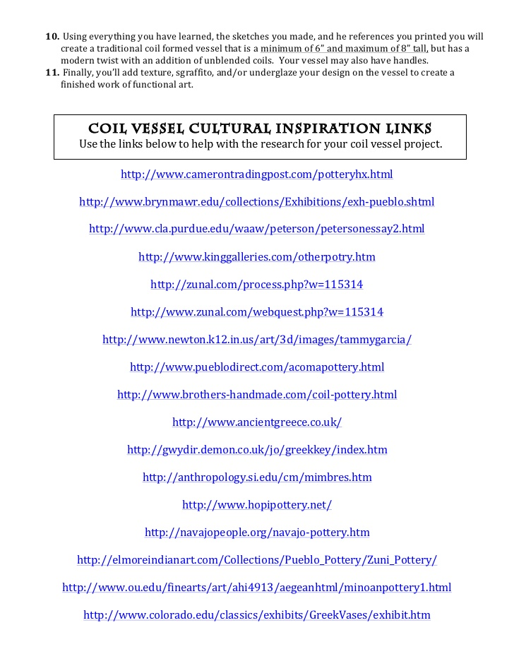Finally, you’ll add texture, sgraffito, and/or underglaze your design on the vessel to create a finished work of functional art.

Name: _______________________________________

**WORKSHEET #1 – FORM & FUNCTION**

Choose FIVE vessel shapes from the cultures you researched and draw a diagram of each vessel shape in the box. Write the culture it is from, the name of the form and describe the function. Being as specific as to how this form would aid in its intended function.

Culture:

Form:

Function:

Culture:

Form:

Function:

Culture:

Form:

Function:

Culture:

Form:

Function:

Culture:

Form:

Function:

**Final Form & reference images**

Choose ONE vessel shape from above and circle it. This will be the form you recreate for your own project. **Print images of this vessel and attach them to this page!**

Name: _______________________________________

**WORKSHEET #2 – COIL PATTERN & DESIGNS**

**Remember:** Your vessel is going to need at least 2” of unblended coils…be sure you have enough designs and sketches to choose from…and that they can work well together for a visually cohesive final piece. Also keep in mind that your 2” of space does not have to be together, it could be spread throughout the piece.

Name: _______________________________________

**WORKSHEET #3 – FINISHING PATTERNS & DESIGNS**

Your final coil vessel will need at least 2 design elements that will be added through texture, sgraffito and/or underglaze. Look at the cultural examples for inspiration and give them a modern twist or interpretation that works alongside the form and coil pattern you have created. You should develop at LEAST 4 different patterns and designs.

**DESIGNS AND MOTIFS with REFERENCE IMAGES**

During your research you should have read about a variety of designs and motifs…they too have specific meaning and symbolism. **Print images of designs & motifs you liked and attach them to this page!**

Name: _______________________________________

**WORKSHEET #4 – final drawing**

Create a symmetrical drawing of your final coil vessel form along with the unblended coil area and your final patterns/designs. This drawing should be well done, have clean lines, be symmetrical and show how your final vessel will look.

**Cultural Inspiration: __________________________________________________________________**

**Name & Function of Vessel Form: _______________________________________________________**

